Create Auto Update Subversion

1. Open folder subversion: C:\Program Files\TortoiseSVN\bin

2. Create File <FileName>.bat

Copy this code:

START TortoiseProc.exe /command:update /path:"E:\Project MINT-CORP\Innovation\SmartHomeCare" /closeonend:1

//Phần màu đỏ là đường dẫn của source trên máy server ( Cần thay đổi )

3. Open Task Scheduler: C:\Windows\system32\taskschd.msc or Run taskschd.msc

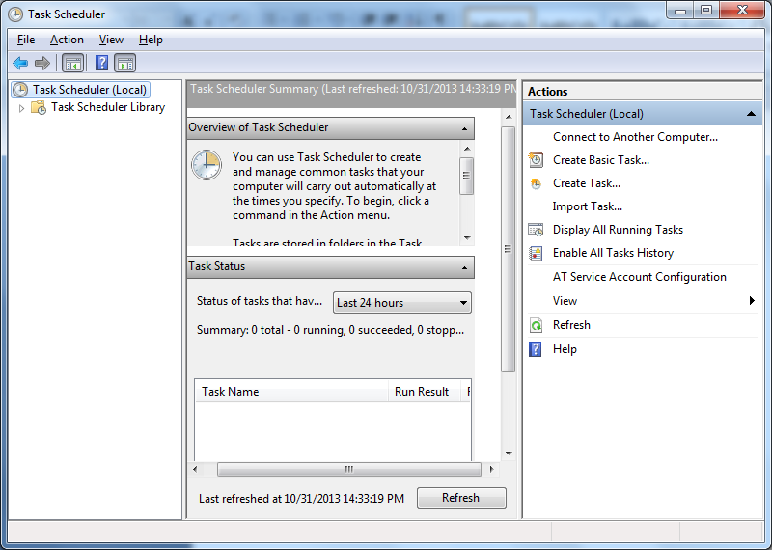

4. Click create task

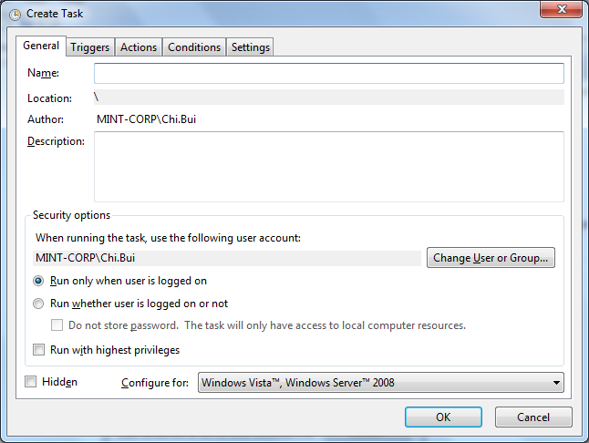

5. Tab Triggers

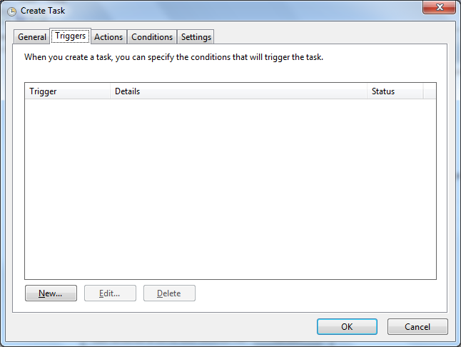

-Click New.. to add scheduler => Select same in picture bottom...

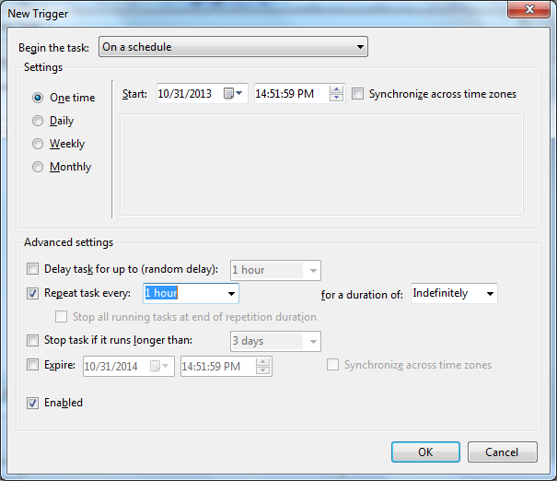

Time repate task

6. Tab Action

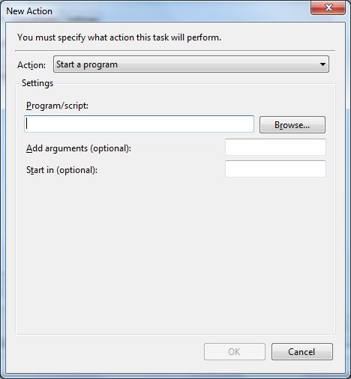

Click Browse... Select file <FileName>.bat has been created in step 1.